Positive words that describe yourself…

What you do well at in work/life…

The things you love, value, or are passionate about…

The things you would like to achieve in life...
Circle the items you think are the best/most important!

You already have all the pieces you need to start developing your brand!
Positive Words = Your Best Attributes
What you do well = Your Strengths
Things you love/value = Your Core Values
Hopeful Achievements = Your Goals

I am [positive words], that [what you do well], who is guided by [things you value/love] to achieve [hopeful achievements].
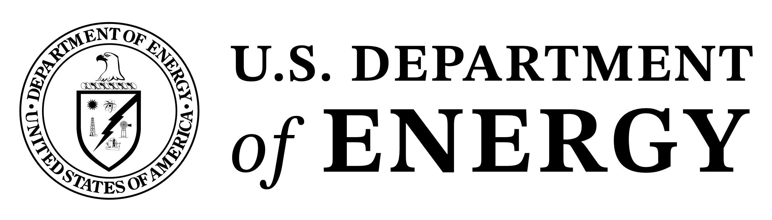
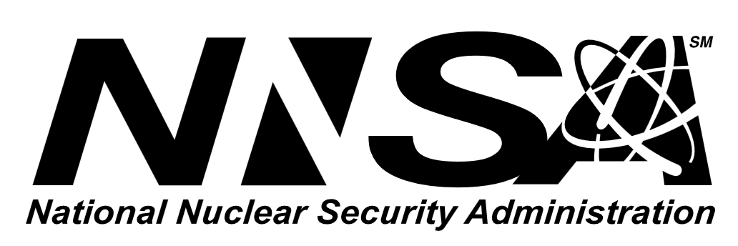
Sandia National Laboratories is a multimission laboratory managed and operated by National Technology & Engineering Solutions of Sandia, LLC., a wholly owned subsidiary of Honeywell International, Inc., for the U.S. Department of Energy's National Nuclear Security Administration under contract DE-NA0003525. SAND2025-13223O

